H.T No
Regulations:
A15


Sreenidhi Institute of Science and Technology
(An Autonomous Institution)
Code No: 5D301 Date: 15-June-2019 (AN)

B.Tech II Year I-Semester External Examination, June-2019 (Supplementary)
Discrete Structures and Graph Theory (ECM)

Time: 3 Hours Max.Marks:75

Note: a) No additional answer sheets will be provided.
b) All sub-parts of a question must be answered at one place only, otherwise it will not be valued.
c) Missing data can be assumed suitably.

Part - A Max.Marks:25

Answer all QUESTIONS.

1. | Construct the truth table for the formula (Q Ʌ(P→Q))→P | [3M]
2. | Symbolize is the predicate: “A is a father of mother of B” | [3M]
3. | Define a monoid and give an example. | [3M]
4. | Determine the number of non-negative integers less than 10⁹ that contain digit 1. | [3M]
5. | Find a recurrence relation for digit ternary sequences that have an even number of 0’s | [3M]
6. | What is the largest possible number of vertices in a graph with 35 edges and all vertices are of degree at least 3. | [2M]
7. | Show that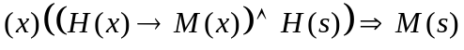 | [2M]
8. | Find coefficient of 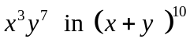 | [2M]
9. | Prove that for any polyhedral graph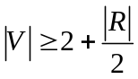. | [2M]
10. | State generalized principle of inclusion and exclusion. | [2M]
Part – B Max.Marks:50
ANSWER ANY FIVE QUESTIONS. EACH QUESTION CARRIES 10 MARKS.

11. | a) | Without constructing the truth table Show that 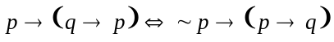 | [5M]
 | b) | Show the following using indirect method of proof. | [5M]
12. | a) | Show that 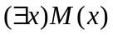 logically follows from the premises 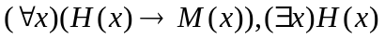 | [5M]
 | b) | Prove or disprove the following argument  “All living things are either plants or animals  David’s dog is a living thing but not plant  All animals have heart  Hence David’s dog has heart” | [5M]
13. | a) | Prove that if the relation R is a partial order on a set A then R⁻¹ is partial order on A. | [5M]
 | b) | Let 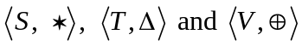 be semigroups and 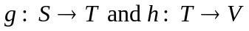be semigroup homomorphisms. Then prove that 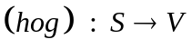is a semigroup homomorphism from 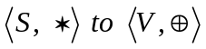 | [5M]
14. | a) | How many non negative integral solutions are there to 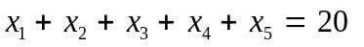 | [5M]
 | b) | Compute the number of integers between 1 and 1000 that are not divisible by 2, 3, 5 or 7? | [5M]
15. | a) | How many different license plates are there that involve 1,2 or 3 letters followed by 4 digits. | [5M]
 | b) | Solve using generating functions the recurrence relation | [5M]
16. | a) | In a connected simple planar graph show that |E| ≤ 3|V|-6 | [5M]
 | b) | Define a Hamiltonian graph. Construct a graph on 6 Vertices which is not Eulerian but Hamiltonian | [5M]
17. | a) | A committee is to be chosen from a set of 9 women and 5 men. How many ways are there to form a committee if the committee has (i) 6 people, 3 women and 3 men? (ii) Any number of people but equal number of women and men. | [5M]
 | b) | Obtain the principal disjunctive normal form of 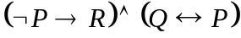 using its principal conjunctive normal form | [5M]
18. | a) | Find a recurrence relation and give initial conditions for the number of bit strings of length ‘n’ that do not have two consecutive 0’s | [5M]
 | b) | If G=(V,E) is a connected plane graph, show that | V | - | E | + | R | = 2. | [5M]
-- 00 -- 00 –

